**15. Probabilistic CFG Parsing**

**Aim:**  
To implement probabilistic CFG parsing for a sentence.

**Algorithm:**

1. Define a probabilistic CFG.
2. Use NLTK’s ViterbiParser to parse the sentence.
3. Display the most probable parse tree.

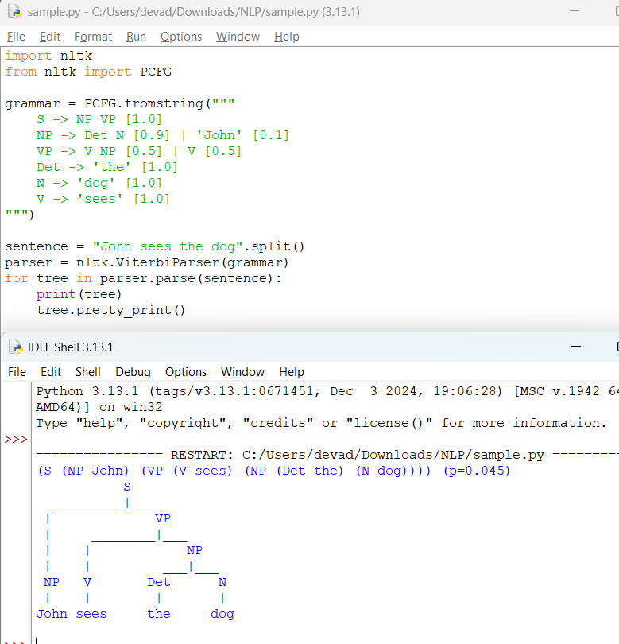

**Result:**  
The probabilistic parser successfully identifies the most probable parse tree.